**Practical 5**

**Configure IP routing using RIP**

**Aim:** Configure IP routing using Routing Information Protocol (RIP)

**Theory:**

RIP (Routing Information Protocol) is a standardized Distance Vector protocol, designed for use on smaller networks. RIP was one of the first true Distance Vector routing protocols, and is supported on a wide variety of systems. RIP adheres to the following Distance Vector characteristics:

• RIP sends out periodic routing updates (every 30 seconds)

• RIP sends out the full routing table every periodic update

• RIP uses a form of distance as its metric (in this case, hopcount)

• RIP uses the Bellman-Ford Distance Vector algorithm to determine the best “path” to a particular destination Other characteristics of RIP include:

• RIP supports IP and IPX routing.

• RIP utilizes UDP port 520 • RIP routes have an administrative distance of 120.

• RIP has a maximum hopcount of 15 hops. Any network that is 16 hops away or more is considered unreachable to RIP, thus the maximum diameter of the network is 15 hops. A metric of 16 hops in RIP is considered a poison route or infinity metric.

We study the RIP protocol using the following network

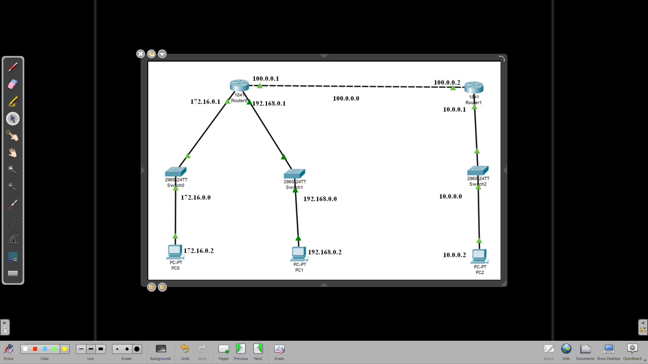

By Default Routers have 2-interfaces in most of the cases, but in our case we need 3-interfacces for Router 0, hence we need to add one interface in Router 0

Now we configure the PC’s and Routers as follows

**Step 1: Configuring PC0**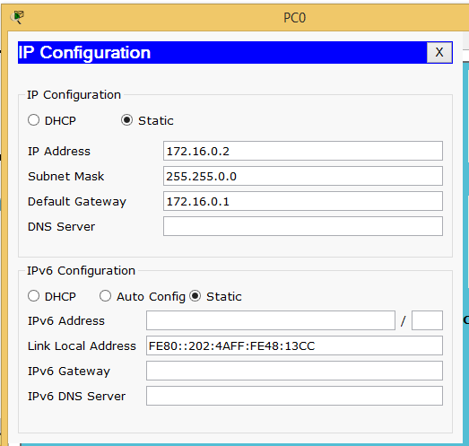

**Step 2: Configuring PC1**

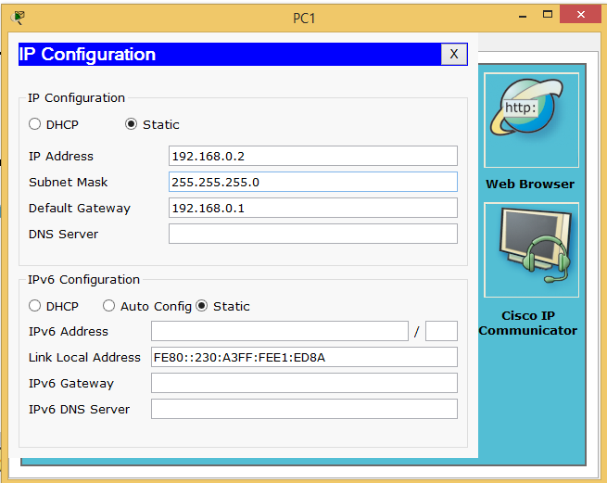

**Step 3: Configuring PC0** 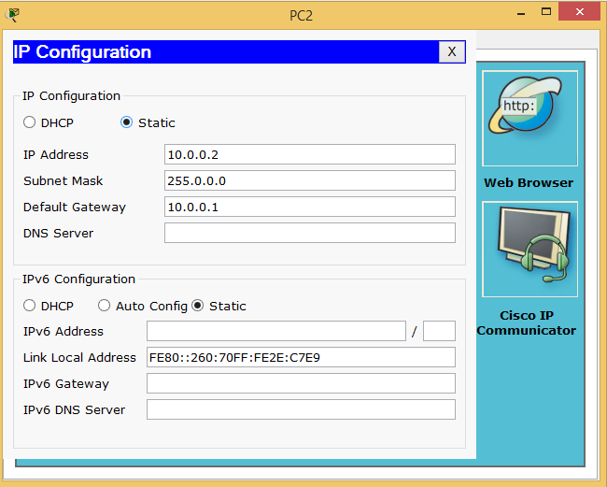

**Step 4: (configure Router 0)**

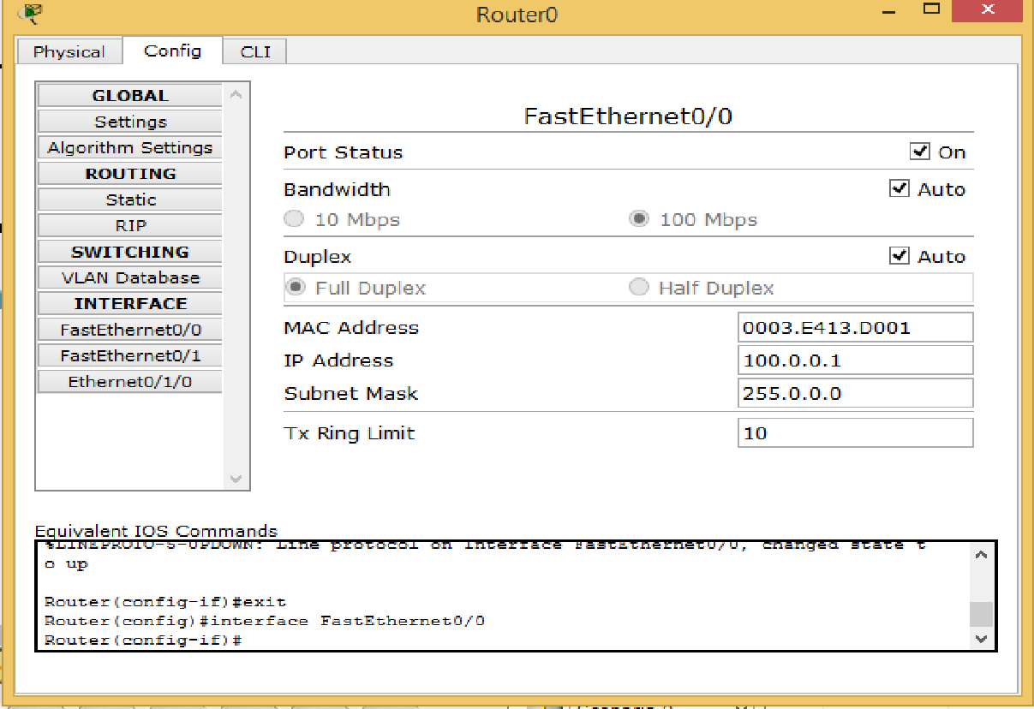

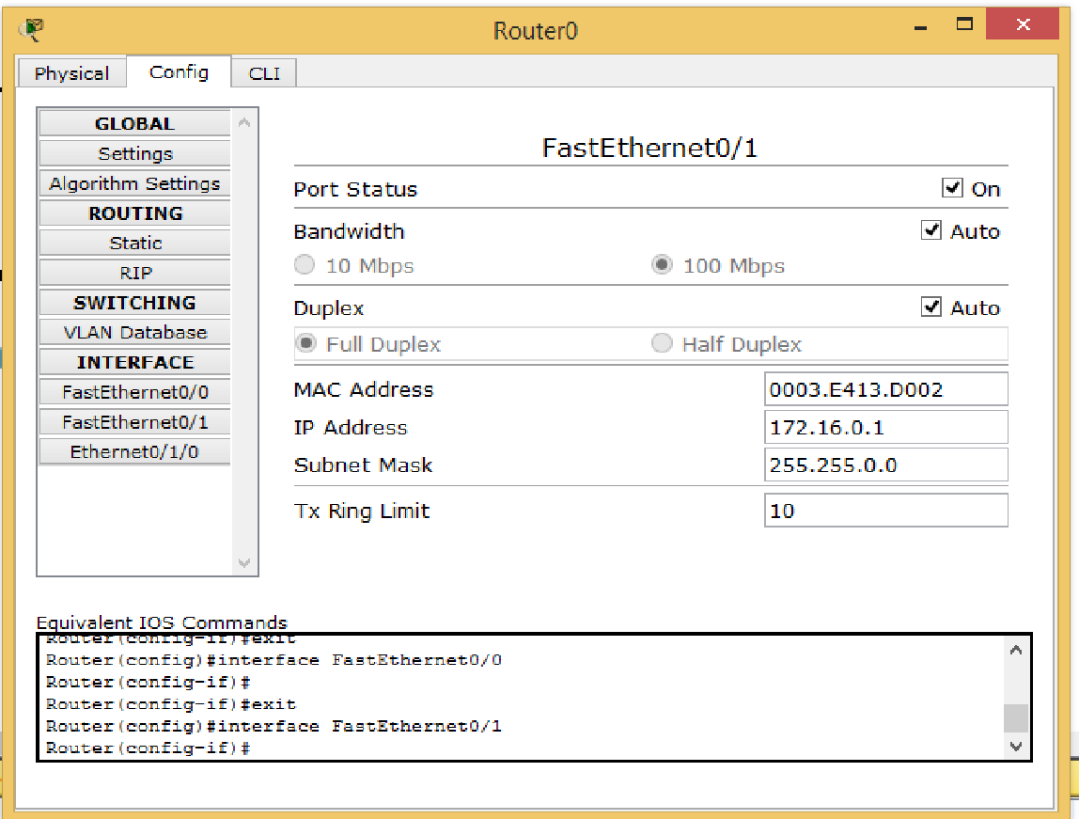

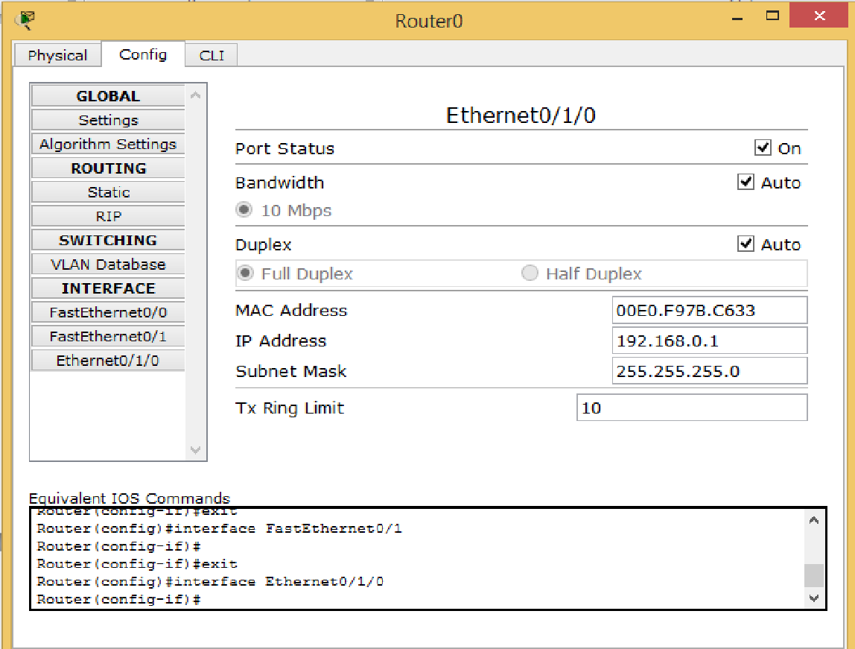

**Step 5: (configure Router 1)**

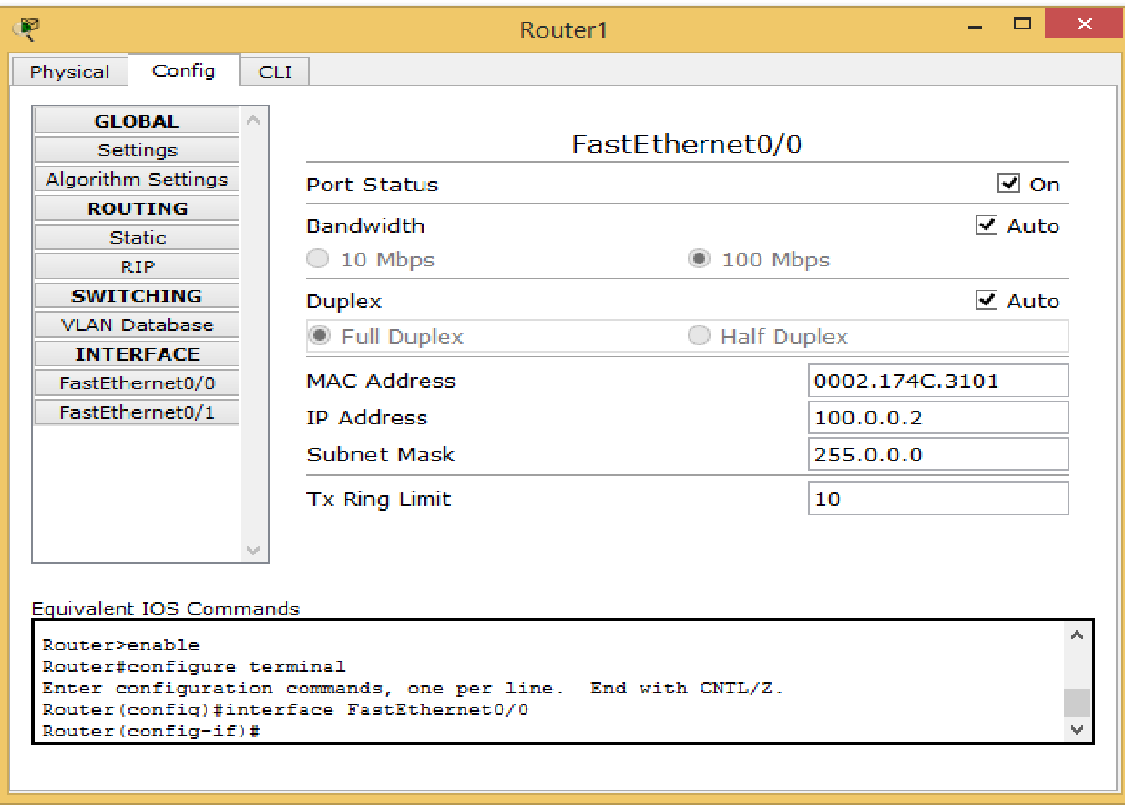

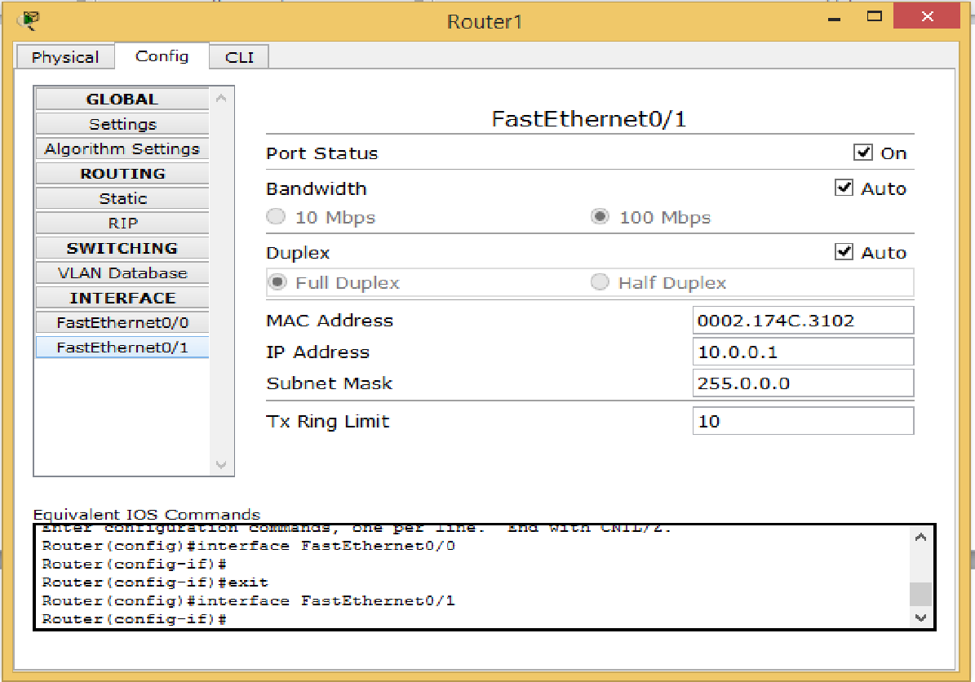

Now we configure the routing table for both the routers

**Routing table for Router 0**

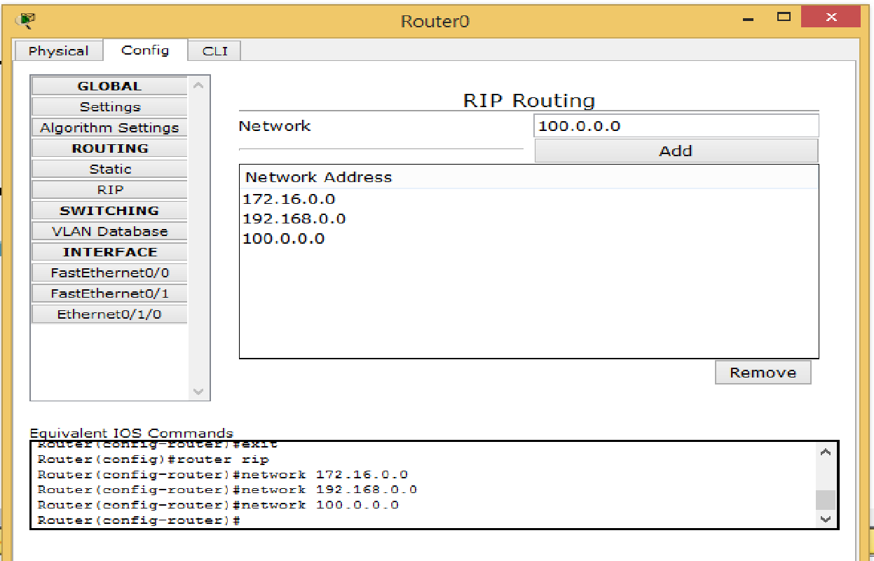

**Routing table for Router 1**

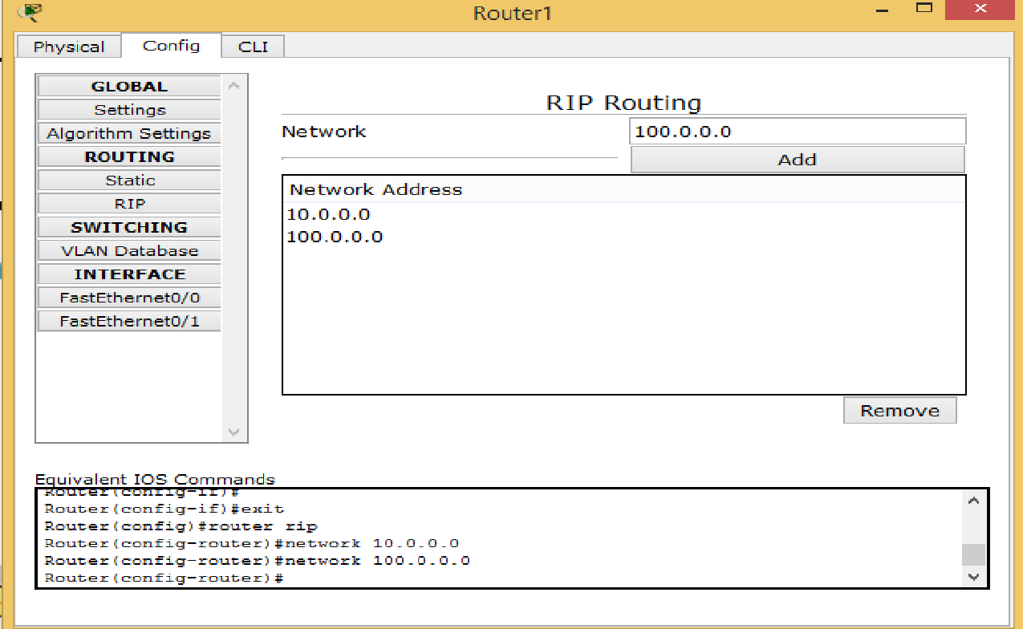

Now we use the ping command to check the working

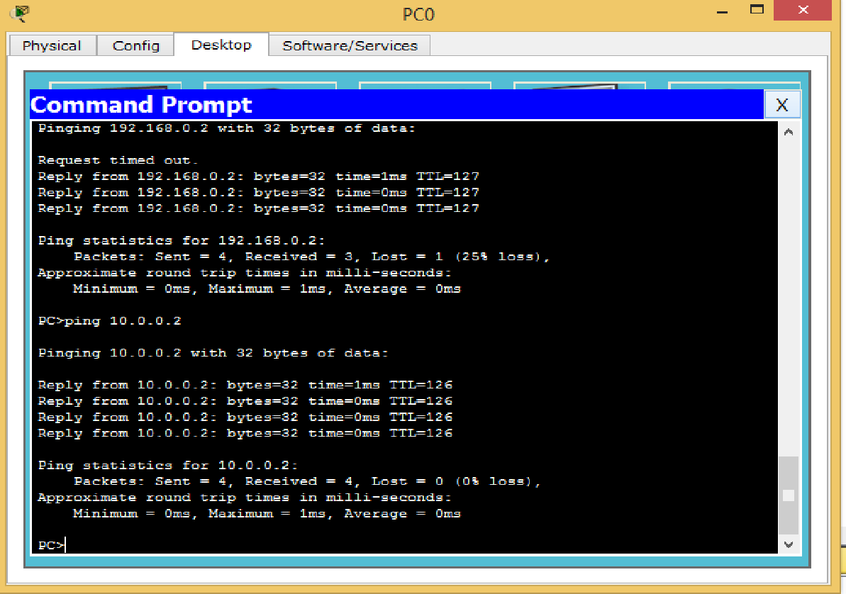

Hence the RIP protocol has been studied

| For Video demonstration of the given Practical, scan the QR code |  |
| --- | --- |